**Basic Experiment 1:**

1. **An explanation of the experiment (including parameters used)**

*population size: 100*

*mutation rate: 1*

*elitism: 1*

*crossover method: none*

*chromosome length: 100*

*selection method: ranked*

*Fitness: One for All!*

*max generations: 500*

*Simply ran the simulator with these parameters; testing impact of mutation.*

1. **A hypothesis (might just be a guess)**

*Think it will converge to high 90s or get all 1s within 250 generations*

1. **Description of the results including plots**

Flatlined at the 100th generation; peaked at ~96; never reached all 1s

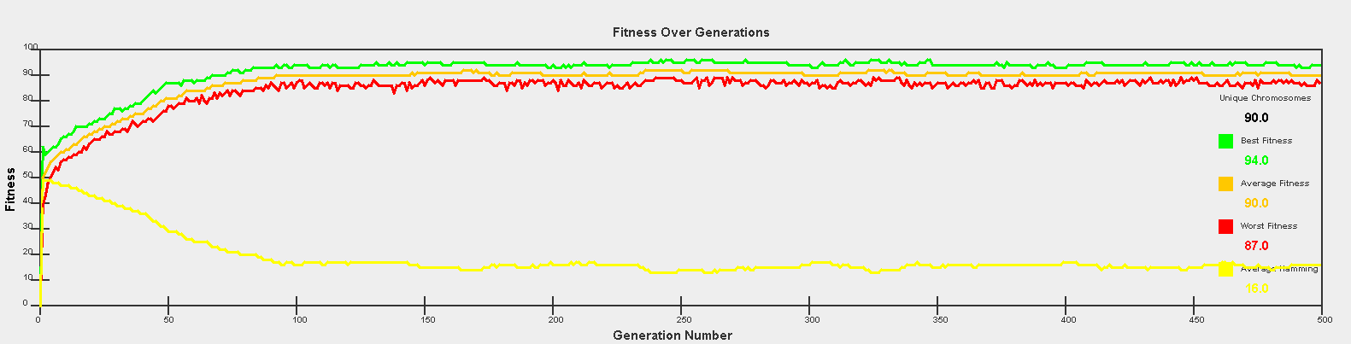

­­­­

1. **What if anything you can conclude and anything you learned or affirmed by doing so?**

Low mutation rate without crossover has steady fitness growth, but is not effective enough to get 100 fitness. Too much mutation to not falter at the 90 mark.

**Basic Experiment 2:**

1. **An explanation of the experiment (including parameters used)**

*population size: 100*

*mutation rate: 1*

*elitism: 1*

*crossover method: yes*

*chromosome length: 100*

*selection method: ranked*

*Fitness: One for All!*

*max generations: 500*

*Simply ran the simulator with these parameters; testing impact of crossover WITH mutation.*

1. **A hypothesis (might just be a guess)**

*Think it will do better than just mutation since there is a swap of genes between parents, which helps hone in on an optimal solution*

1. **Description of the results including plots**

Gets perfect fitness in less than 100 generations. Still often hovers around 97-99 for 25-50 generations depending on the seed

All ten trial runs: 47, 83, 72, 82, 86, 93, 81, 63, 76, 72.

1. **What if anything you can conclude and anything you learned or affirmed by doing so?**

Crossover is indeed incredible useful when performing evolution. The gene swapping really plays into converging to an optimal solution the fastest

**Basic Experiment 3:**

1. **An explanation of the experiment (including parameters used)**

*population size: 100*

*mutation rate: 0*

*elitism: 1*

*crossover method: yes*

*chromosome length: 100*

*selection method: ranked*

*Fitness: One for All!*

*max generations: 500*

*Simply ran the simulator with these parameters; testing impact of only crossover*

1. **A hypothesis (might just be a guess)**

*Think it will do much worse without mutation, since it is literally just swapping genes back and forth, it cannot explore different bit string combinations.*

1. **Description of the results including plots**

It levels out at around generation 50, and completely flatlines.

Still achieves low 90s in fitness

All ten trial runs: 88, 91, 94, 96, 85, 93, 96, 91, 92

1. **What if anything you can conclude and anything you learned or affirmed by doing so?**

Crossover is still incredibly useful in getting good results in evolution, but mutation is necessary to get the very best results, otherwise you will completely plateau.

**Basic Experiment 4a:**

1. **An explanation of the experiment (including parameters used)**

*population size: 100*

*mutation rate: 15*

*elitism: 1*

*crossover method: yes*

*chromosome length: 100*

*selection method: ranked*

*Fitness: One for All!*

*max generations: 500*

*Simply ran the simulator with these parameters; testing impact of HIGH mutation*

1. **A hypothesis (might just be a guess)**

*Think it will do much worse, since it will continually mutate, never having a chance to converge*

1. **Description of the results including plots**

It levels out immediately and never gets above low 70s at best.

Not surprising, predicted the outcome in the hypothesis.

1. **What if anything you can conclude and anything you learned or affirmed by doing so?**

Mutation rate should always stay low! Or else it will never converge.

**Basic Experiment 4b:**

1. **An explanation of the experiment (including parameters used)**

*population size: 100*

*mutation rate: 1*

*elitism: 50*

*crossover method: yes*

*chromosome length: 100*

*selection method: ranked*

*Fitness: One for All!*

*max generations: 500*

*Simply ran the simulator with these parameters; testing impact of HIGH elitism*

1. **A hypothesis (might just be a guess)**

*Think it will do as well as crossover with mutation, since we are repeatedly reusing the best.*

1. **Description of the results including plots**

Converges in about 55 generations.

Did even better than mutation with crossover.

Trying the same with elitism >50 has very minor improvements

1. **What if anything you can conclude and anything you learned or affirmed by doing so?**

Elitism is a very powerful tool, but its marginal utility depletes quickly as it increases.

**Basic Experiment 4c:**

1. **An explanation of the experiment (including parameters used)**

*population size: 100*

*mutation rate: 1*

*elitism: 1*

*crossover method: yes*

*chromosome length: 50*

*selection method: ranked*

*Fitness: One for All!*

*max generations: 500*

*Simply ran the simulator with these parameters; testing impact low chromosome length*

1. **A hypothesis (might just be a guess)**

*Think it will converge considerably quicker, since there are less bits to mutate and the overall fitness (unnormalized) is smaller.*

1. **Description of the results including plots**

Converges in less than 50 generations

On average obtained 100 fitness in 63 generations

Steeper climb than any other test; jumps almost immediately to 80

1. **What if anything you can conclude and anything you learned or affirmed by doing so?**

The fewer the genes, the less work the simulation must do to converge on a solution. This is obvious, but good to test to make sure the simulation works correctly.

**Basic Experiment 5a:**

1. **An explanation of the experiment (including parameters used)**

*population size: 100*

*mutation rate: 1*

*elitism: 1*

*crossover method: yes*

*chromosome length: 100*

*selection method: ranked -> roulette ->truncation -> ranked -> truncation -> steady-state -> tournament*

*Fitness: One for All!*

*max generations: 500*

*We will be testing impact of changing selection methods. The idea is to run the simulator on the default parameters with different seeds and see what happens as we alternate from one to the other. The selection methods themselves are not very important, rather the process of shifting form one to the other.*

1. **A hypothesis (might just be a guess)**

*The fitness will improve at first, then do worst, then recover. Fitness functions will not build on each other, but rather converge to their individual fitness.*

1. **Description of the results including plots**

Hypothesis stood correct except for the trade off between truncation and ranked, however, both are very similar selection methods, so they are not necessarily feeding off of each other.

Significant drop when using steady-state, and significant increase when tournament. This is to be expected since these are the lowest and highest performing selection methods respectively.

(ranked -> roulette at 50; roulette > truncation at 150; switching between truncation and ranked from 200 to 300; steady-state begins at 300; tournament begins at 400).

1. **What if anything you can conclude and anything you learned or affirmed by doing so?**

Certain selection methods are better than other, and it is important to understand the difference when running simulations. Your model may have poor performance because of your choice.

**Basic Experiment 5b:**

1. **An explanation of the experiment (including parameters used)**

*population size: 100*

*mutation rate: 1*

*elitism: 1*

*crossover method: yes*

*chromosome length: 100*

*selection method: stochastic universal sampling*

*Fitness: One for All! -> Absolutely! -> Target -> One for All!*

*max generations: 500*

*We will be testing impact of changing fitness functions. The idea is to run the simulator on the default parameters with different seeds and see what happens as we alternate from one to the other. The fitness functions themselves are not very important, rather the process of shifting from one to the other. The selection method is also not very important, so SUS was used since it generally performs well*

1. **A hypothesis (might just be a guess)**

*The fitness will act the same as it did when trying out different selection methods*

1. **Description of the results including plots**

Hypothesis was incorrect. Fitness drops down (which is obvious because the definition of a “fit” individual changes) when the function changes, but it recovers relatively quickly. One for All! -> Absolutely! at 100; Absolutely -> Target at 200; Target to One for All! at 410.

Since Absolutely’s criteria for fitness is skewed towards 50, it should be said that this function will not begin to converge to 100 like the others

1. **What if anything you can conclude and anything you learned or affirmed by doing so?**

Fitness functions do a good job at converging even when they are being swapped around. When looking at this through a biological lens, an environmental change, could result I completely different fitness functions. Say everything gets 30 degrees colder, now animals with fur are more fit than those who could stand the hot sun. This requires these animals to evolve and adapt, where specific mutations will be more favorable and passed on.

**Reproduce Experiment:**

1. **An explanation of the experiment (including parameters used)**

*population size: 1000*

*mutation rate: 0*

*elitism: 0*

*crossover method: yes*

*chromosome length: 20*

*selection method: roulette wheel*

*Fitness: One for All!*

*max generations: 500*

*We will be attempting to reproduce the result of the paper “How Learning can Guide Evolution” by Geoffrey E. Hinton and Steven J. Nowlan. We created new classes for the new genes (with 1s, 0s, and ?s), as well as a new chromosome and population to hold these types. These were then used in conjunction with a roulette wheel style selection method as well as the One For All! fitness function. This served to*

1. **A hypothesis (might just be a guess)**

*If everything goes as planned (aka the paper is reproduced correctly, we should see the graphs of correct, incorrect, and undecided alleles that are shown in the paper).*

1. **Description of the results including plots**

Our plot looks somewhat like the one in the paper. Our incorrect alleles quickly drop to zero, while our correct alleles hover around 35 and our undecided alleles hover around 70. These two alleles should be swapped and the best/average/worst fitness display erroneous values, but overall we had a functional algorithm. It seems as if the number of ?s was higher than expected.

(black = 0; light gray=correct alleles; dark grey=undecided alleles).

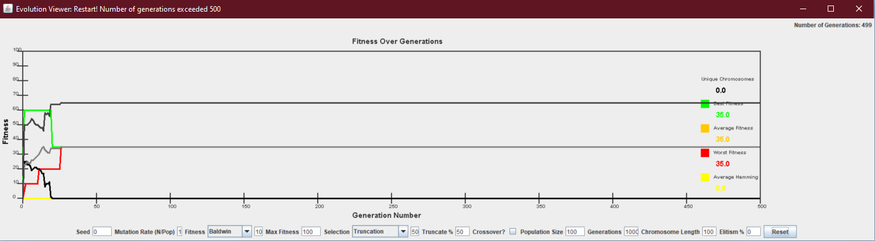

1. **What if anything you can conclude and anything you learned or affirmed by doing so?**

Although our results differ from those of the of the paper, we found that Baldwin Effect is reaffirmed by our attempt to reproduce the historic experiments. Overall we have realized the meaningful distinction between Lamarckian and Baldwin theories of evolution. Most importantly it is the ability to learn at an enhanced rate that can can provide an evolutionary advntage rather than the actual content. Thus, in terms of evolution it is not what organisms learn but how organisms learn that effects the species.